Jr. Solar Sprint Regulations

Materials:
- One (1) solar panel and one (1) motor are allowed per car. The recommended kit Junior Solar Sprint Kit from Solar Made, includes a 3 W solar panel and 3 V motor. Any replacement kit needs to match those specifications or should be within the 2.7-3.2 W window for the solar panel and 1.5-3 V for the motor.

- Reflectors, supports, and power leads can be added to these components as needed. All components must be firmly attached to the vehicle.
Note: If the motor breaks due to high solar panel power outputs, this will result in automatic disqualification of the race. The vehicle must be able to run with the motor that will be inspected the day of.
- The remainder of the vehicle must be your own design and can be made from any other material (plastic, wood, cardboard, etc.)

Vehicle Specifications:
- The vehicle must be safe to contestants and spectators, e.g., no sharp edges, projectiles, etc.
- The vehicle must fit the following dimensions: 11 ¾ in. by 18 in. by 11 ¾ in.
- A 3 cm. by 3-cm. space must be left for the assigned car number.
- The sun’s light is the only energy source that may be used to power the vehicle. No batteries or energy storage devices are permitted.
- The vehicle must be steered by the guide wire using one or more eyelets affixed to the vehicle. The vehicle must be easily removable from the guide wire, without disconnecting the guide wire.
- The body of the car must be three-dimensional. Teams will NOT be allowed to bolt the axles and wheels to the solar cell. The solar cell cannot be used as the body of the car.

Track Specifications:
- The length of the racecourse is 30 meters over flat terrain.
- Race lanes are at least 24 in. wide.
- The guide wire will be located in the center of the track and will not be more than 1.5 cm. above the track surface.
- The track is a hard, flat smooth surface such as a tennis court or running track. A large sheet of rolled material, i.e., plastic, heavy paper, or roll roofing (half-lap), or hardwood taped or bolted together may be used to cover an unsuitable surface.

Conduct of the Race:
- At race time, the vehicle will be placed behind the starting line with all its wheels in contact with the ground and an opaque sheet covering, but not touching the solar panel. The opaque sheet will be removed at the start of the race, allowing the vehicle to collect solar power and start driving.
- An early or push start may result in disqualification or a re-run of the heat. The determination will be left to the race judges.
- All vehicles will be started when the official signal is given. The winner of the heat will be the first vehicle to cross the finish line or the farthest car down the lane.
- During the initial heats, the judges may declare multiple wins or losses.
- One team member must wait at the finish line to catch the vehicle.
- Team members may not accompany or touch the vehicle on the track. Vehicles stalled on the track may be retrieved after the end of the race has been declared.
- The vehicle and team member must remain at the finish line until the order of the race has been established.
- Lane changing, or crossing will result in disqualification. (At the discretion of the judges).
- Challenges must be made before the race judges begin the next heat. All challenges must come from the team members who are actively competing. The decisions of the race judges are final.
- Judges have the option to inspect cars prior to the final heat or at any time during/after heats.

Materials:
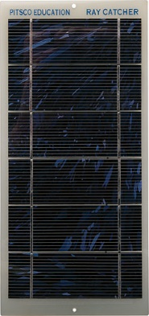
1. One (1) solar panel and one (1) motor are allowed per car. The recommended kit Junior Solar Sprint Kit from Solar Made, includes a 3 W solar panel and 3 V motor. Any replacement kit needs to match those specifications or should be within the 2.7-3.2 W window for the solar panel and 1.5-3 V for the motor.
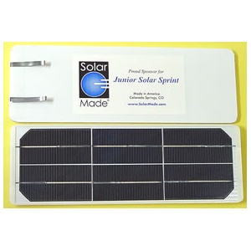
Examples of solar panels:

SolarMade Pitsco
Monocrystalline Polycrystalline
Solar Panel: Solar Panel:

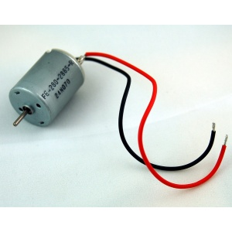
Examples of motors:
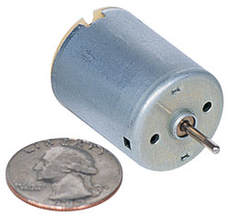

2. Reflectors, supports, and power leads can be added to these components as needed. All components must be firmly attached to the vehicle.
Note: If the motor breaks due to solar panel overload of power, this will result in automatic disqualification of the race.
3. The remainder of the vehicle must be your own design and can be made from any other material (plastic, wood, cardboard, etc.)
Vehicle Specifications:
4. The vehicle must be safe to contestants and spectators, e.g., no sharp edges, projectiles, etc.
- The vehicle must fit the following dimensions: 11 ¾ in. by 18 in. by 11 ¾ in.
- A 3 cm. by 3-cm. space must be left for the assigned car number.
- The sun’s light is the only energy source that may be used to power the vehicle. No batteries or energy storage devices are permitted.
- The vehicle must be steered by the guide wire using one or more eyelets affixed to the vehicle. The vehicle must be easily removable from the guide wire, without disconnecting the guide wire.
- The body of the car must be three-dimensional. Teams will NOT be allowed to bolt the axles and wheels to the solar cell. The solar cell cannot be used as the body of the car.

Examples of eyelets:

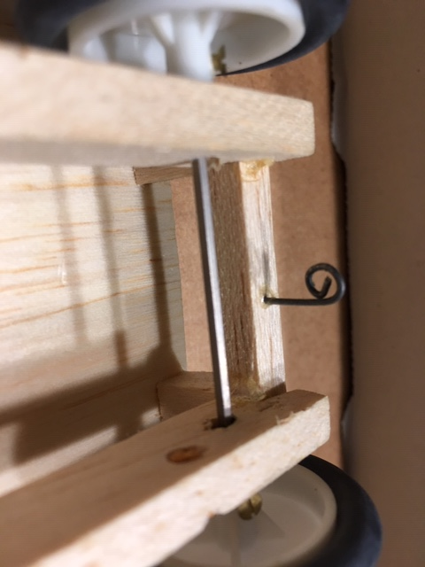

Figure 5. Wire curved with pliers and inserted into wood

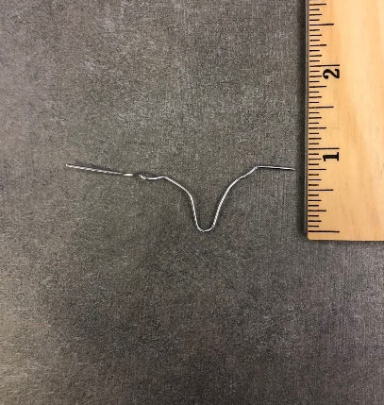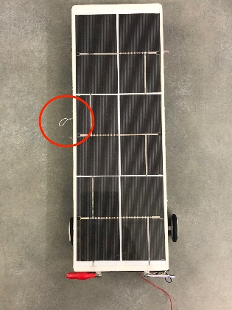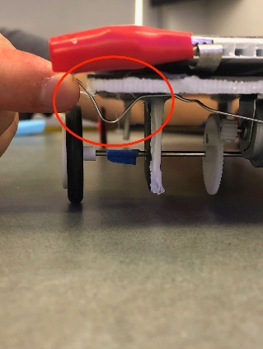
Figure 6. Paper clip refolded and inserted into foam board (base of car)

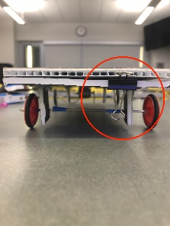
Figure 7. Binder clip attached to foam board with hot glue gun and wire is removed to place guide wire

